A Data Fusion Framework for Covariate Prioritization in Incomplete Short-Term Soil Nitrogen Records

Research Report
This document contains the account of how the analysis reached its current form. Detailed version notes are in CHANGELOG.md; the full final methods and validation are in the v3.1 model report. Both documents can be accessed on the research repository https:/github.com/aairori2/Soil-Nitrogen-Data-Fusion-Framework
The study began with the curiosity of combining remote sensing data and five years of soil data, from a cover crop grazing and fertilizer experiment, to assess the potential of soil carbon forecasting. However, after the audit of the data, we found soil inorganic nitrogen (NH₄⁺, NO₃⁻) to be the only consistent variable across the years of sampling (Table 1). Thus, the soil carbon project became a soil nitrogen project, because the coverage audit showed carbon could not support the question being asked.
After running several iterations of the model, as will be demonstrated below, it became clear that five years of agronomic data at this sampling density is too short for forecast modeling. The global GPR predictions also reverted to the prior mean, which is what happens when the model extrapolates beyond the range of data it was fitted to, and it indicated that the model itself would need restructuring, not only more data. Thus, the project pivoted to focus on methodological development, which is more transferable than the forecast would have been.
Study Area
9 one-acre plots · 3 randomized treatments (unfertilized triticale, fertilized triticale, triticale + legume) · grazed and ungrazed plots ·0–10 and 10–20 cm · 2019–2023 · 1,363 soil samples
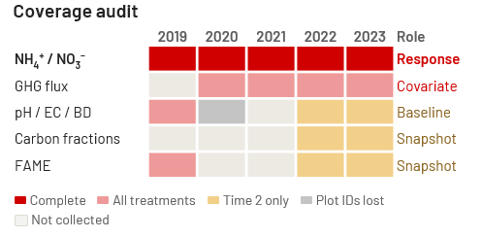
Table 1. The coverage audit of the available data across the years of field experiment.
Model Version Development
Below is a table describing the model development. Each version answered one question and raised the next.
Version | Question it asked | What it settled
v1.0 | Can soil carbon fractions carry a trajectory model? | No, too few years and treatments
v2.0 | What variable can? | Soil inorganic nitrogen, the only one with full coverage; along with NDVI, EVI and VV backscatter from Google Earth Engine
v2.1 | What drives it? | Ranking needed before modelling; drought index added (SPEI)
v3.0 | Does Green House Gas flux help? | CO₂ ranks high in training, fails out of sample
v3.1 | Can any of these predict N projection? | No, and the limit is the length of the record

v1.0 Experimental Baseline
Five years of records were standardized into a single schema, with sample identifiers encoding year, plot, time point, depth, grazing condition and replicate. The first model fitted Gaussian Process regression to soil organic carbon fraction data against year alone, with no covariates.
Carbon fractions were found to be the most precise data in the study with several different fractions recorded including FPOM, OPOM and MAOM, but they only existed for two years at one sampling time in 2022 and 2023. A model fitted with them describes a snapshot, not a trajectory. Precision at the bench does not substitute for coverage in the design. This catalyzed an audit of every variable's coverage, rather than a choice of variable based on scientific interest.

v2.0 Anchor Model
The coverage audit established soil inorganic nitrogen (NH₄⁺, NO₃⁻) as the only variable measured across all five years, all three treatments, and both sampling times. It became the modelling anchor by default. Therefore, the study's framing had to change from carbon to nitrogen. That was not a preference but a constraint: a variable measured in one treatment cannot test a treatment effect, regardless of how well it was measured.
Two additions followed. Grazing entered as an explicit factor once grazed and ungrazed plots were recognized as distinct sampling units rather than just replicates. And remote sensing covariates were extracted per plot and sampling window: NDVI and EVI from Sentinel-2, VV backscatter from Sentinel-1 utilizing Google Earth Engine (GEE).

v2.1 Covariate Ranking
An annual standardized precipitation evapotranspiration index (SPEI) was extracted manually and joined the covariate set. Random Forest (RF) impurity importance was introduced to rank covariates before fitting the Gaussian Process Regression (GPR), which is our main forecasting model. The nitrogen target was log-transformed, which stopped the model from producing negative concentrations. With several covariates available we were able to start identifying which covariates to include in the GPR model. Covariate Ranking made that decision explicit rather than arbitrary choosing the variables.

v3.0 Green House Gas Flux
Chamber greenhouse gas flux (CO₂, N₂O, CH₄, Hutchinson–Mosier) that was collected on multiple sampling windows during the experimental was added as a covariate, aggregated to a seasonal mean per plot, year and grazing plot. We rerun the RF impurity importance and add Permutation importance for comparison in covariate ranking.
CO₂ flux ranked third under RF impurity importance for both analytes yet shuffling it using Permutation importance improved held-out prediction. The RF model had learned a CO₂–nitrogen pattern that did not transfer between years. One ranking method alone would not have caught that. The RF model was further tested using leave-one-year-out cross-validation, which returned negative R² in every fold; therefore, we reframed this method as a covariate ranking tool rather than a predictive model for covariate projection.
The projection horizon was also shortened from 2024-2030 to 2024-2028 to match the length of the 5 years of observed record.

v3.1 Final Model
Three structural changes.
One global model. v3.0 fitted eighteen separate Gaussian Processes, one per treatment × grazing × depth combination. Inside each, treatment, grazing and depth were constant and could carry no effect: the visible separation between trajectory lines came from fitting different subsets, not from a modelled effect. So, we decided to correct this in v3.1 by fitting a single model over all 264 plot-level rows, with those three variables as model inputs instead of just as constant.
A third covariate ranking method. The anisotropic (ARD) Matérn kernel assigns one length-scale per input dimension, giving a relevance ranking intrinsic to the Gaussian Process and independent of Random Forest. Three methods now rank the covariates by three different mechanisms.

GPR model validation. Before we project the global GPR model from 2024-2028. The model was fitted to 2019–2022 and asked to predict the held-out 2023 season, to report the error metrics alongside credible-interval coverage and width.
The drought index was also re-extracted per sampling window from gridded data from GEE, which offers more comprehensive SPEI data, replacing the annual value used through v3.0.

Corrections worth knowing about
Several reported findings changed when errors were found. The full list is in CHANGELOG.md; two mattered most.
- A placeholder drought value manually added propagated through v2.1 and v3.0, holding 2021 at −2.10 and 2022 at +0.88. Replacing it with gridded data reversed part of the interpretation: 2021 was near-normal, 2022 was the driest year in the record, and the relationship between water balance and inorganic nitrogen is inverse rather than suppressive.
- "T1" and "T2" in the study's availability table denote Time 1 and Time 2, not Treatment 1 and Treatment 2. Carbon fractions, FAME profiles and pH/EC in 2022–2023 therefore cover all three treatments at a single sampling time, which changed their analytical role from descriptive only to a snapshot comparison.

Results

Covariate ranking
Year and water balance (SPEI) rank highest under impurity importance and ARD length-scales; grazing ranks last or near-last under all three methods. Permutation importance cannot evaluate year-level covariates under year-grouped folds. Year is constant within the held-out season, and SPEI takes only two values there, one per sampling window, which are too close to move any sample across a split threshold. Year and SPEI therefore return exactly zero for both analytes, reflecting the limitation of the fold design rather than the covariates' contribution.
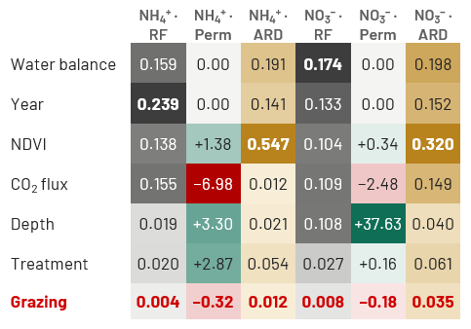
Table 2. The comparison between the three covariate ranking models; Random Forest impurity importance (RF), Permutation importance (Perm), and Anisotropic Matérn kernel (ARD) for soil inorganic nitrogen (NH₄⁺, NO₃⁻). RF and ARD values are shares of total relevance. Permutation is the change in held-out mean squared error when a covariate is shuffled; negative means shuffling improved prediction. The scales are not comparable between methods.

Grazing effect
The two 2023 unfertilized results are significant after Holm correction within the 2023 endpoint family of six tests (p = 0.036 for NH₄⁺, 0.030 for NO₃⁻). We treat the end point of 2023 as the primary contrast because grazing effects accumulate across seasons, so the endpoint after four grazing season is where the question is asked. Neither result would survive correction across all 22 comparisons in the table, where the threshold falls to roughly 0.002. The choice of family therefore determines the outcome and was made after the results were seen, so it is reported explicitly rather than left to an uncorrected p-value. Legume plots were not samples in 2020, while 2019 predate grazing and is excluded.
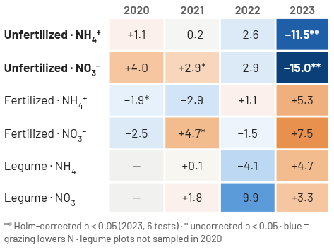
Table 3. Describe Grazed minus ungrazed, mg kg⁻¹, by Mann–Whitney U within treatment and year.

Predictive validation

The model predicted the held-out season poorly: R² was −3.26 for NH₄⁺ and −1.83 for NO₃⁻, with RMSE of 22.3 and 17.5 mg kg⁻¹. Negative R² means the predictions were worse than simply using the test-set mean. This happens because 2023 lies outside the range of years the model was fitted to, so no nearby training data pulls the prediction in any particular direction and it reverts to the prior mean, the model's default expectation in the absence of information. Every held-out observation therefore received a near-identical prediction regardless of its plot, treatment or depth, and the credible intervals widened for the same reason. Interval coverage of 100% is not a success, because those intervals are wider than the full observed range of either analyte, so every observation falls inside them trivially. This is why coverage is reported alongside interval width in Figure 1.

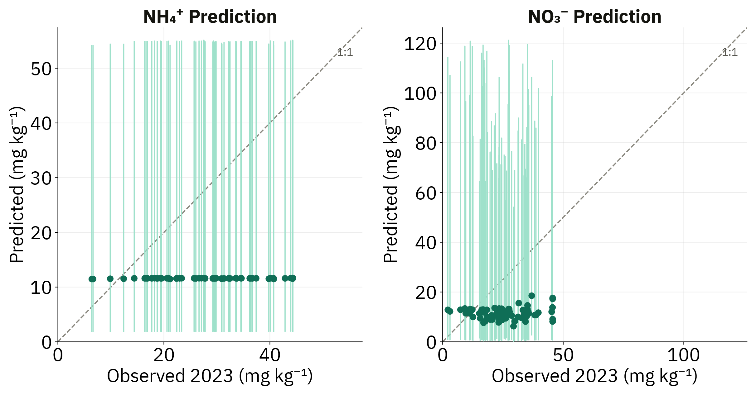
 | NH₄⁺ | NO₃⁻
RMSE (mg kg⁻¹) | 22.3 | 17.5
R² | −3.26 | −1.83
95% interval coverage | 100% | 100%
Mean interval width (mg kg⁻¹) | 53 | 88
Figure 1. Plotted predicted values against observed values (mg/kg) for both NH₄⁺ and NO₃⁻.

Discussion
A covariate can carry a real, conditional effect without being a useful global predictor. This was observed with grazing where it ranked last or near-last under every method, yet grazed unfertilized plots lost 11.5 mg kg⁻¹ NH₄⁺ and 15.0 mg kg⁻¹ NO₃⁻ by 2023, with no equivalent effect where fertilizer or legume nitrogen was present. The three importance ranking methods utilized asks whether a variable separates the whole dataset; a variable acting within just one treatment cannot do this, therefore, this covariate was ranked last even though it has significant effects withing the singular treatment of Unfertilized Triticale in 2023. Furthermore, to address the issue of limited soil data, grouping folds by plot ID, as Lucero et al. (2026) did, may suit sparse soil records better than the year-grouped folds used here, though it tests generalization to new plots rather than to new years. Another limitation related to the remote sensing data is the small plot size relative to the drought index grid. Nine one-acre plots share a single 4.6 km pixel, so SPEI varies in time but not in space, unlike the 10 m vegetation and SAR covariates.
Based on the overall limitations of this model analysis, we conclude that five annual campaigns can only support description and association, not prediction. This is a property of the record length, not of the model or its tunings
However, lengthening the record alone will not be sufficient. Because year is one of the model inputs, any future season sits outside the range the model was fitted to, and the same reversion to the prior mean would occur in 2029 as it did in 2023. The problem would move rather than
disappear. Two further changes are therefore needed. First, the time signal should be carried by the covariates themselves, such as water balance, vegetation index and flux, rather than by year, so that a future season falls inside the observed range of each covariate and the model interpolates instead of extrapolating. Second, any genuine forecast requires future covariate values that are not available, which is why the projection reported here holds them at observed means. A forecast from this framework will therefore always be conditional on an assumed climate and vegetation scenario and should be reported as such.
The Framework
The following framework is therefore proposed based on this study as checkpoints before building a forecasting pipeline on a short record:
- Let coverage decide each variable's role, before modelling anything. Two years at one time point support a comparison, not a trajectory. High-quality data can only do so much if it isn't collected consistently.

- Test conditional variables directly before ranking discards them. Grazing ranked last or near-last under every method tried, yet held the only significant management effect in the study.

- Rank covariates at least two ways, and report the disagreement. CO₂ flux ranked third in-sample while degrading held-out prediction, visible only under permutation.

- Match covariate resolution to your sampling design. An annual drought index on multi-season sampling is collinear with year by construction. Extracted per sampling window, it became testable.

- Run the temporal holdout first because it decides whether the rest is worth building. Report interval coverage with width. Coverage here reached 100% only because the intervals exceeded the full observed range.

Conclusion
The framework is complete and documented. Three improvements are identified but not implemented: nesting feature selection inside training folds so the model's uncertainty is not optimistic, grouping folds by plot as well as by year, and measuring soil moisture at plot resolution so water balance can vary between plots rather than only between sampling windows. A defensible forecast requires three steps rather than one. Extending the record so that the temporal structure becomes estimable rather than guessed, restructuring the model so that covariates rather than year carry the time signal, and reporting any forecast as conditional on assumed covariate values. The temporal holdout, rerun each season, will show when the first of these thresholds are reached.

References
For quick reference, the citations below are grouped according to their respective role in the research project rather than alphabetically listed.

Agronomic context
Lucero, M., Adee, E., Ruiz Diaz, D., Sullivan, T., Jha, G., Simon, L., & Joshi, D. R. (2026). Machine learning insights into long-term soil fertility legacy and seasonal weather effects in corn–soybean rotation. Soil Science Society of America Journal, 90, e70334. doi:10.1002/saj2.70334
Blanco-Canqui, H., Shaver, T. M., Lindquist, J. L., Shapiro, C. A., Elmore, R. W., Francis, C. A., & Hergert, G. W. (2015). Cover crops and ecosystem services: Insights from studies in temperate soils. Agronomy Journal, 107, 2449–2474. doi:10.2134/agronj15.0086
Santos, Erick & Dubeux Jr, José & Mackowiak, Cheryl & Wright, David & Anguelov, Gueorgui. (2023). Integrated crop‐livestock systems result in less nitrate leaching than ungrazed crop systems in North Florida. Journal of Environmental Quality. doi:10.1002/jeq2.20474
Williams SR, Neill F, Cheong S, Chandler-Khayd C, Tautges N, Ji N, Pires AFA and Gaudin ACM (2026) Grazing of cover crops improves soil nitrogen dynamics in organic vegetable systems with minimal soil health tradeoffs. Front. Soil Sci. 6:1825405. doi: 10.3389/fsoil.2026.1825405
Covariate importance and ranking
Breiman, L. (2001). Random forests. Machine Learning, 45(1), 5–32. doi:10.1023/A:1010933404324
Strobl, C., Boulesteix, A.-L., Zeileis, A., & Hothorn, T. (2007). Bias in random forest variable importance measures: Illustrations, sources and a solution. BMC Bioinformatics, 8, 25. doi:10.1186/1471-2105-8-25
Strobl, C., Boulesteix, A.-L., Kneib, T., Augustin, T., & Zeileis, A. (2008). Conditional variable importance for random forests. BMC Bioinformatics, 9, 307. doi:10.1186/1471-2105-9-307
Nicodemus, K. K., Malley, J. D., Strobl, C., & Ziegler, A. (2010). The behaviour of random forest permutation-based variable importance measures under predictor correlation. BMC Bioinformatics, 11, 110. doi:10.1186/1471-2105-11-110
Fisher, A., Rudin, C., & Dominici, F. (2019). All models are wrong, but many are useful: Learning a variable's importance by studying an entire class of prediction models simultaneously. Journal of Machine Learning Research, 20(177), 1–81. jmlr.org/papers/v20/18-760.html
Hooker, G., Mentch, L., & Zhou, S. (2021). Unrestricted permutation forces extrapolation: Variable importance requires at least one more model, or there is no free variable importance. Statistics and Computing, 31, 82. doi:10.1007/s11222-021-10057-z.

Modelling and validation
Rasmussen, C. E., & Williams, C. K. I. (2006). Gaussian Processes for Machine Learning. MIT Press. gaussianprocess.org/gpml
Neal, R. M. (1996). Bayesian Learning for Neural Networks. Lecture Notes in Statistics 118. Springer.
Roberts, D. R., Bahn, V., Ciuti, S., Boyce, M. S., Elith, J., Guillera-Arroita, G., et al. (2017). Cross-validation strategies for data with temporal, spatial, hierarchical, or phylogenetic structure. Ecography, 40(8), 913–929. doi:10.1111/ecog.02881
Ambroise, C., & McLachlan, G. J. (2002). Selection bias in gene extraction on the basis of microarray gene-expression data. PNAS, 99(10), 6562–6566. doi:10.1073/pnas.102102699
Mann, H. B., & Whitney, D. R. (1947). On a test of whether one of two random variables is stochastically larger than the other. Annals of Mathematical Statistics, 18(1), 50–60. doi:10.1214/aoms/1177730491
Holm, S. (1979). A simple sequentially rejective multiple test procedure. Scandinavian Journal of Statistics, 6(2), 65–70. Used to correct the grazing comparisons within the 2023 endpoint family.

Data sources
Gorelick, N., Hancher, M., Dixon, M., Ilyushchenko, S., Thau, D., & Moore, R. (2017). Google Earth Engine: Planetary-scale geospatial analysis for everyone. Remote Sensing of Environment, 202, 18–27. doi:10.1016/j.rse.2017.06.031
Huete, A., Didan, K., Miura, T., Rodriguez, E. P., Gao, X., & Ferreira, L. G. (2002). Overview of the radiometric and biophysical performance of the MODIS vegetation indices. Remote Sensing of Environment, 83(1–2), 195–213. doi:10.1016/S0034-4257(02)00096-2 Source of the EVI formulation.
Vicente-Serrano, S. M., Beguería, S., & López-Moreno, J. I. (2010). A multiscalar drought index sensitive to global warming: The standardized precipitation evapotranspiration index. Journal of Climate, 23(7), 1696–1718. doi:10.1175/2009JCLI2909.1
Abatzoglou, J. T. (2013). Development of gridded surface meteorological data for ecological applications and modelling. International Journal of Climatology, 33(1), 121–131. doi:10.1002/joc.3413

